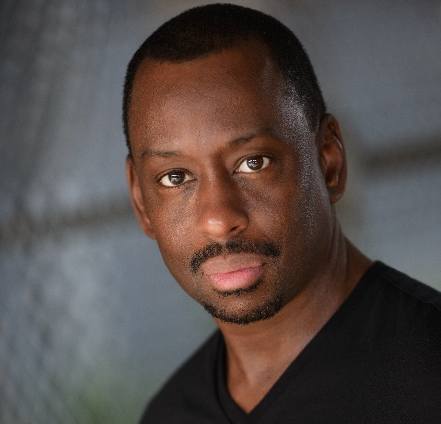

JEFFRY FOOTE
AEA
Hair: Black Eyes: Brown Height: 5’8”

FILM
Loveland | Supporting | Feature Film, Dir. Jeffrey Scott
Golden | Featured | Short Film, Without Bounds
Deceit | Featured | Web Series, Dir. Stephen Coombs
Grey | Lead | NYU Student Film, Dir. Sania Jhankar
Steady Hands | Supporting | Short Film, Broken Moon Productions
Crash Course | Supporting | Short Film, Dir. Bryan Huth
The Circle | Featured | Short Film, Dir. Aida Mestour
Diary of a Badman | Featured | Feature Film, Deniran Films
One Last Time | Supporting | Short Film, Dir. Donell Clark
The Pledge | Lead | Short Film, Dir. Eric Lau
The Body | Supporting | Short Film, Dir. Chante Osborne
OFF-BROADWAY
Don’t Bother Me, I Can’t Cope | Ensemble | New York City Center, Dir. Savion Glover
REGIONAL
One Flew Over the Cuckoo’s Nest | Dr. Spivey | Hudson Theatre Works, Dir. Frank Licato
Of Mice and Men | Crooks | Hudson Theatre Works, Dir. Frank Licato
The Man Who Came to Dinner | John | Surflight Theater, Dir. James Bond
A Raisin in the Sun | Walter Lee Younger | Conservatory Players, Dir. Maren Sugarman
Six Degrees of Separation | Paul | Barn Theater, Dir. Don Miller
Wind in the Willows | Chief Weasel/Guard | Garage Theater, Dir. Michael Bias
Dark of the Moon | John | Dragonetti Theater, Dir. Barry Scott
Riffin’ & Tappin’ | Buck | Depot Theatre, Dir. Chris Patterson
42nd Street | Ensemble | Jersey Shore Entertainment, Dir. Paula Sloan
Ragtime | Booker T. Washington | Surflight Theater, Dir. Chris Kahler
Hairspray | Ensemble | Surflight Theater, Dir. Karen Babcock
A Tribute to the Rat Pack | Sammy Davis Jr. | Soldier Hill Players, Dir. Randy Accardi
Dance Bojangles Dance | “Sand Man” Sims | Brooklyn Theater Arts Project, Dir. Chris Patterson
Dreamgirls | Marty | Plays in the Park, Dir. Chris Patterson
TRAINING
On Camera Class: Alison McBryde, Kimberly Graham, Karlee Fomalont, Amanda Richardson, Skyler Zurn, Dariush Kashani, Dani Super, Eric Lau, Actors Connection, HB Studios,
Commercial Class: Doreen Frumkin
Acting: Frank Licato, Barry Scott
Rhythm Tap: New Jersey Tap Ensemble, Deborah Mitchell, Omar Edwards, Ted Levy
Voice: Barbara Farruggia

SPECIAL SKILLS
Professional Tap Dancer, Stage Combat, Voice-Overs, Southern Accent, Martin Lawrence Impersonation

